**Project Report on**

**"Design and Development of Payment Operated Automatic Paper Glass Fed Liquid Dispenser Machine"**

***Submitted in partial fulfilment of the requirement***

***for the degree of***

**BACHELOR OF TECHNOLOGY**

**IN**

**MECHANICAL ENGINEERING**

**Submitted by**

**PRATEEK SHAMPRASAD PAWAR**

**(PRN NO: 2015BME002)**

**PRASAD SHAMRAO DESHPANDE**

**(PRN NO: 2015BME016)**

**BHAGWAN PANDITRAO SAVANDKAR**

**(PRN NO: 2015BME017)**

**NIRANJAN MOHAN MANE**

**(PRN NO: 2015BME032)**

**MANTHAN NITIN DHISALE**

**(PRN NO: 2015BME051)**

**Under the guidance of**

**MR. P.B. CHOUGULE**



**Department of Mechanical Engineering**

**WALCHAND COLLEGE OF ENGINEERING, SANGLI**

**2018-2019**

**DECLARATION**

We hereby declare that the project report entitled “**Design and Development of Payment Operated Automatic Paper Glass Fed Liquid Dispenser Machine**” submitted by us to Walchand College of Engineering, Sangli in fulfilment of the requirement for the award of degree of B. Tech. in Mechanical Engineering is a record of bonafide project work carried out by us under the guidance of Mr. P. B. Chougule. We further declare that the work reported in this project has not been submitted and will not be submitted, either in part or in full, for the award of any other Degree/Diploma in this institute or any other institute or university.

Date:

Place: Sangli

Prateek Shamprasad Pawar

(2015BME002)

Prasad Shamrao Deshpande

(2015BME016)

Bhagwan Panditrao Savandkar (2015BME017)

Niranjan Mohan Mane

(2015BME032)

Manthan Nitin Dhisale

(2015BME051)

**CERTIFICATE**

This is to certify that the project work entitled “**Design and Development of Payment Operated Automatic Paper Glass Fed Liquid Dispenser Machine**” submitted by

Prateek Shamprasad Pawar (2015BME002)

Prasad Shamrao Deshpande (2015BME016)

Bhagwan Panditrao Savandkar (2015BME017)

Niranjan Mohan Mane (2015BME032)

Manthan Nitin Dhisale (2015BME051)

in partial fulfilment of the requirement for the degree of “Bachelor of Technology (Mechanical Engineering)” is a record of their own work carried out under my supervision during the year 2018-19.

Date:

Mr. P.B. Chougule

(Project Guide)

The candidate has completed all the required phases of evaluation and performed satisfactorily. Hence, recommended for the partial fulfilment of the requirement for the said degree.

External Examiner Head

Department of Mechanical

Engineering

**ACKNOWLEDGEMENT**

We would like to express my sincere gratitude to **Mr. P.B. Chougule** for his guidance and his continuous support, encouragement, help extended at every stage of this works.

We express my gratitude and earnest thanks to **Prof. Dr. U. A. Dabade**, Head of Mechanical department for their thorough support to my project.

We would like to take this opportunity to thank the entire individuals who have supported us directly or indirectly in accomplishment of my project. We are thankful to the faculty of mechanical engineering department for helping us in various aspects. Non-teaching staff of mechanical engineering department has been instrumental in completion of my project.

Prateek Shamprasad Pawar

(2015BME002)

Prasad Shamrao Deshpande

(2015BME016)

Bhagwan Panditrao Savandkar

(2015BME017)

Niranjan Mohan Mane

(2015BME032)

Manthan Nitin Dhisale

(2015BME051)

**ABSTRACT**

Water has become the most commercial products of the century. The stress on the multiple water resources is a result of many factors. On the one hand, the rapidly rising population and changing lifestyles have increased the need for fresh water. The problem of need of water at the low cost and to provide it as per the need of individual is well known. So, the water need to be provided as per need at low cost to quench thirst is important.

All we need to do is to storage of water, Paper glass and electricity source for the machine and it’s done. It has a feature that allows the customer to pay and purchase without being assisted by anyone. So there is a need to provide sufficient safe drinking water with minimum cost and without using plastic bottles or glass causing pollution and solid waste is also not biodegradable so impacting the environment adversely. The vending machine dispenses water the when coin is inserted in it. It follows the process of filling of the paper glass from the loaded stack of paper glass. The volume flow rate of water is calculated on the basis of metering system using sensors and the volume of water collected in glass which is being served to the passer-by is calculated and given using paper glass.

This is a product which will be the connecting link between government organizations and individuals or NGOs or companies to have such water distribution system which will aid in public welfare. Even companies can install such machines leading to reduced supply chain costs incurred presently and also to reduce overall cost as product is directly supplied to the end user. Even this system can be utilized for other beverages by proper changes.

**TABLE OF CONTENTS**

|  |  |  |  |  |  |
| --- | --- | --- | --- | --- | --- |
| **Chapter No.** | | | **Title** | | **Page No** |
| **1** |  |  | **INTRODUCTION** | | **1** |
| **2** |  |  | **LITREATURE REVIEW** | | **3** |
| **3** |  |  | **PRE-PROJECT OBJECTIVES** | | **6** |
| **4** |  |  | **IDEATION** | | **7** |
|  | **4.1** |  | **Payment** | | **7** |
|  |  | **4.1.1** | | **Cash payment** | **7** |
|  |  | **4.1.2** | | **Card payment** | **7** |
|  |  | **4.1.3** | | **Using online banking / UPI** | **8** |
|  | **4.2** |  | | **Paper Cup Vending** | **8** |
|  |  | **4.2.1** | | **Removing from stack manually** | **9** |
|  |  | **4.2.2** | | **One cup separator manually operated** | **9** |
|  |  | **4.2.3** | | **Automatic Cup separator** | **9** |
|  |  | **4.2.4** | | **Water filling** | **10** |
|  |  | **4.2.5** | | **Water flow time control** | **11** |
|  | **4.3** |  | | **Flow sensor** | **11** |
| **5** |  |  | | **DESIGN** | **13** |
|  | **5.1** |  | | **Coin Detector** | **13** |
|  | **5.2** |  | | **Metering System** | **15** |
|  | **5.3** |  | | **Cup Separator Mechanism:** | **16** |
|  |  | **5.3.1** | | **Servo Motor** | **16** |
|  |  | **5.3.2** | | **Cup Separator** | **16** |
| **6** |  |  | | **CONTROLLING UNIT** | **18** |
|  | **6.1** |  | | **Hardware** | **18** |
|  | **6.2** |  | | **Software** | **19** |
|  | **6.3** |  | | **IDE** | **19** |
|  | **6.4** |  | | **Flow chart and Program** | **20** |
| **7** |  |  | | **FABRICATION** | **26** |
|  | **7.1** |  | | **Cup separator** | **26** |
|  | **7.2** |  | | **Cup separator mechanism** | **27** |
|  | **7.3** |  | | **Sliders for mechanism** | **27** |
|  | **7.4** |  | | **Guide for cup** | **28** |
|  | **7.5** |  | | **Frame** | **29** |
|  | **7.6** |  | | **Cup stacks support** | **29** |
| **8** |  |  | | **COST ANALYSIS** | **30** |
| **9** |  |  | | **CONCLUSION** | **33** |
| **10** |  |  | | **PROJECT WORK FLOW** | **34** |
| **11** |  |  | | **REFERENCES** | **35** |

**LIST OF FIGURES**

|  |  |  |
| --- | --- | --- |
| **Figure No.** | **Title of Figures** | **Page No.** |
| **1** | **Pie chart of number of vending machine** | **3** |
| **2** | **Card payment** | **8** |
| **3** | **One cup separator manually operated mechanism** | **9** |
| **4** | **Weight measuring cup** | **10** |
| **5** | **Ultrasonic detector** | **11** |
| **6** | **Flow sensor (Component)** | **12** |
| **7** | **Flow sensor (Design)** | **15** |
| **8** | **Cad model of coin separator mechanism** | **17** |
| **9** | **Cup separator mechanism CURA CAM simulation** | **26** |
| **10** | **Cup separator Mechanism** | **27** |
| **11** | **Sliders for mechanism** | **28** |
| **12** | **Cup guide pipe** | **28** |
| **13** | **Cup holder** | **29** |
| **14** | **Cup stack support** | **29** |

1. **INTRODUCTION**

**Need for water dispensing unit in Indian Scenario-**

In hot sunny day or in general while moving on roads, doing rigorous exercise, anywhere the

thing required by everyone is water to quench thirst. Low Water level in the body leads to

dehydration and which is very lethal to the life.

Ensuring clean drinking water from a trusted water source such as an RO water purifier or

water filtered through RO + UV technique or water stored from above sources is what the

time demands and one cannot compromise in its purity. So the proposed project will serve as

a platform for payment based paper glass fed water dispensing machine, which will be

storing safe and clean water from government facilities or commercial pure water suppliers.

With a vending machine, we need not to hire an employee for serving water. Neither we have

to be present all the day and in night also it will provide service, as a machine it will be free

from fatigue which is the behaviour of normal employee. All we need to do is to stock of

water, Paper glass and electricity source for the machine and it’s done. It has features that

allows the customer to purchase and pay without being assisted by anyone.

So there is a need to provide sufficient safe drinking water with minimum cost and without

using plastic bottles or glass causing pollution and solid waste is also not biodegradable so

impacting the environment adversely, instead using paper glasses that will be eco-friendly

and all losses to environment as it is recyclables. Normal human requires 6-8 glasses of water

daily, when thirsty customer can drink water by using paper glass only instead of going for a

litre water bottle which is so costly and generating waste and which they are not completely

emptying, but drinking 1or 2 glass of water and carrying remaining water along with them at

destination where there is plenty of water available so for proper utilization of water and

supplying required amount of water only, to the customer. Also if they will carry metallic

bottles they can get water at less price than usual. By installing such machines at crowded

locations, heavy traffic streets, bus stops, railway stations, commercial malls, etc. optimum

utilization of water without plastics can be achieved and target customer is lower and middle

class section of society.

This is a product which will be the connecting link between government organisations and

individuals or NGOs or companies to have such water distribution system which will aid in

public welfare. Even companies can install such machines leading to reduced supply chain

costs incurred presently and also to reduce overall cost as product is directly supplied to the

end user. Even this system can be utilized for other beverages by proper changes.

This is the age of technology and ours is a sincere effort to develop an environment friendly

affordable water vending facility.

**2. LITREATURE REVIEW**

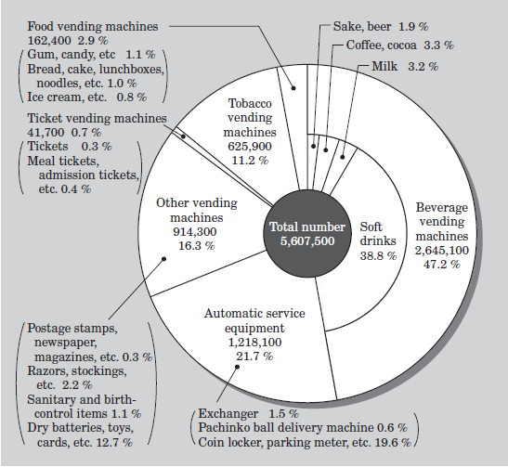

**Fig 1: Pie chart of number of vending machine**

According to survey conducted in Asia- Pacific region by Vending

Machine Manufacturers Association (VMMA) the various vending machines and their

Quantity contribution is shown in Fig.1. Out of which a major contribution of 47.2 % comes

From Beverage, Vending. One of the leading manufacturers in Asia-Pacific and Fuzzy Electric first introduced Bottle and Cup vending technology in Japan.

The Primary challenges in cup and bottle vending were compliance to Environmental

Regulation and Energy Saving Laws, that created obstacles in Refrigerating technology and

Plastic Cup cans to be vended. Research leading to Non-Freon refrigerants satisfied one of

the compliances. But still the environment friendly storage and dispensing compliance was

unanswered. PET (Polyethylene Terephthalate) bottles and cups mostly 500mL bottle sizes,

was the only alternative for effective liquid vending storage cans. This compliance was

considered as a challenge for the proposed project to issue an environment-friendly vending

[1]. However, the term Automated Vending Machine (AMV), took a while longer to place its

first steps in India subcontinent. The technology was noticed more frequently at later 2011. A

‘Vending Machine’ is defined as a device that sells all types of food and drink and diverse

items in which you pay some change and select which item you wish for (Web Finance, Inc.,

2011) [2]. If we go by Answers.com, it means a coin-operated machine to trade products

(Answers Corporation, 2011) [3].

Now-a-days the existing supply chains for liquid distribution, more preferably the Water

Distribution network of Maharashtra and Karnataka Government is one of the schemes under

“Swatchha Jal Abhiyan”. However, though the water rates and purity are far better, a lot

many money is wasted in distribution channel. As per a survey conducted in Haryana

alternative ‘Consumer chain cycles’ of vending Machine for standardized services to all

consumers [4] (Donaldson et al., 2006,p.177). was proposed. A lot many supply chain costs

could be cut-off if Vending Machine technology is introduced. One of such business models

was proposed by ‘Manohar Bharat’[5]-

* There should be an Automated Vending Machine at every village with more than

5000 populations in Haryana which have at-least 8 hours of electricity per day

(irrespective of timings).

* There need to be at least 1 and maximum 2 local agents in that village.
* Though ‘Consumer chain cycles’ supply chain does not eradicate employment related

To distribution completely, but suggests an alternative for women employment and

empowerment in this sector. Focus is also given to suit this current product based

project on Indian Platforms [6][7][8].

One of the major challenges in any vending technology is the mode of Payment. This issue is

very much dependent upon the type of vending machine, the target audience, the region in

which it serves, the money designations and lot many. One of such ways include a coin

operated payment, proposed by Alfonso Carlosena et al. [9] describe about different coin

accepting sensors include optical sensors, electromagnetic sensor, impact sensor, acoustic

sensor. This classification is based on principles of detecting coin. By this technique the

cheapest service can be provided even in the age of 2018! Jesus E. Ibarrola and at all [10]

Coin selector is mechanism which is a way or path for the coins, along which are fitted with

different sensors like optical and electromagnetic sensors and at least one rocker arm

mechanism located at the entrance to that path which is responsible for directing the coins

towards the correct path. It includes a permanent magnet and a fixed magnetic relay close to

that magnet, the magnet is fitted on the rocker arm and located towards the entrance to the

path for the coins. The displacement of the rocker arm pulls the magnet, varying the action of

magnetic field on the relay. The relay is connected to a power supply circuit for

the sensor, which is activated when a coin is introduced detector for the presence of coins

consists of a mobile permanent magnet and a fixed magnetic relay, located close to the

magnet. The magnet is fitted to a lever located in the selector in the path of the coins, close to

the entrance, this lever being freely displaceable by the passage of each coin introduced and

serving to pull the magnet as it is displaced.

One of the pre-requisites in vending technology is the Rack Management (Stack of

paper/plastic cups, containers) in which the liquid can be dispensed efficiently. Friedrich

Graffen berger [11] [12], patented a cup-dispensing mechanism for the addressed issue. This

invention relates to dispensing means and more particularly to a cup dispensing machine.

This is to be used in case of stacked paper cups. There were many other patents for the cup

dispenser prior to this patent but all of them involved complicated mechanisms like gear or

detachable latches for supporting and separating the cups from stack. These machines were

more complex and expensive to manufacture as accuracy required in manufacturing for these

machines was higher. This patent proposes a cup dispensing machine which has minimum

number of parts involved and also the accuracy required is less with low power consumption.

However, the challenge here is to evolve and modify this patented mechanism for low cost

and less energy consumption techniques, which is very well taken care of in this project by

using an additive manufacturing technique of 3D print and Arduino based control. According

to Patent filed by L.T. Leet [13] vending machine in which liquid container and a cup

reservoir placed on stand. The open end of the container kept on a conical s apex holder, this

arrangement is such that the fluid flows into a cooling chamber, that is it provided to control

the quantity of liquid contained. Connection of the cooling chamber within which is mounted

a vertically-operated plunger which displaces a required amount of liquid, which flows into a

dispenser, from which it can be drawn by the operator through a suitable valve. That is it also

provided for supplying a cup for holding the liquid. The operation of the plunger and the cup

supplying means are controlled from a common source which is operated by the rotation of a

handle, upon which are mounted coin-controlled mechanisms for releasing positively

operated pawls, which are adapted to lock the mechanism against motion the patent satisfies

all the needs required for our intended application and so used in separating cups from stack.

**3. PROJECT OBJECTIVES**

1. To study different mechanical and electronic principles involved in the automation project.
2. To select appropriate sensors and actuators for constructing various mechanisms involved in the automation project.
3. To design and fabricate mechanisms for metering and automatic feeding .
4. To execute a proper algorithm based program for Arduino controlled sensors and actuators for the intended application.

**4. IDEATION**

There are mainly three components to be worked for given problem statement:

1. Payment.
2. One paper cup from stack.
3. Heating system for hot water.
4. Filling specific amount of water.
5. Developing IOT system for smart dispenser.

These components can be fulfilled using different types of mechanisms and operations. We considered these all alternatives for basic ideation and feasibility study.

* 1. **Payment**

**4.1.1 Cash payment**

The cash payment is most simple and commonly used type of the payment method in vending machines. The problem statement states that our product has to provide a cup of water and hence price will be nearly 2 rupees. For the 2 rupees there can be coin or notes used but as detection and handling of the notes is very difficult and problem causing hence we restricted our payment method to coin operations. The coin detection is comparatively easy and modules for the coin detection are readily available. These modules are compatible to Arduino and can be used for identifying one type of coins. The overall cost of this method is less but it requires the availability of coin with the customer.

**Advantages:**

* Easy for using for customers.
* No internet connection required.

**Disadvantages:**

* No real time monitoring possible
* Transactions to be monitored manually.

**4.1.2 Card payment:**

The payment using credit or debit card is an easy way and useful in cashless transactions. Making the card payment requires a setup for card payment and continuous internet connection to the setup. The connection can be given by using Wi-Fi modules now available even in remote areas. Having an internet connection to the setup can also be used for IOT based real time monitoring of the setup. This setup has more cost but more convenience.

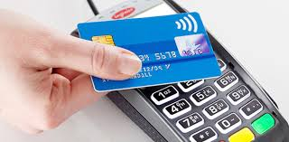

**Fig 2: Card payment**

**Advantages:**

* Easy tracking and recording of transactions.
* More secure than cash payments.

**Disadvantages:**

* Requires card for every customer.
* Requires network connection.

**4.1.3 Using online banking / UPI**

The payment using the UPI code is latest development in the money transactions. This type of payment is easy and fast but requires internet connection to the customer. The connection to the customer can also be given using Wi-Fi module but this has security issues. Also even if customer has internet connection and the payment is made, the signal about payment made or failed is to be given to the setup which ultimately needs an internet connection. This payment option also requires more investment and security threat due to the internet connection.

**Advantages**:

* More convenient and fast use.
* More secure payment.

**Disadvantages**:

* Requires internet connection for both customer and setup.
* Can be more time consuming in online transactions.

Depending on the advantages and disadvantage of different payment methods as above, the most feasible and easy method is accepting coins in cash from customers and providing them the service.

**4.2 Paper Cup Vending:**

**4.2.1 Removing from stack manually:**

Removing one cup at time from stack of cups can be easily done manually with hand. This is risky if one customer takes more than one cup or complete stack for other usage. This also has possibility of theft from other people. This mechanism is easy but not feasible to use in given case.

**Advantage:**

* No power required for the working of mechanism.
* No possibility of problem in receiving cup.

**Disadvantages:**

* No security to the paper cup stack.

**4.2.2 One cup separator manually operated.**

Removing one cup from stack can be done using a cup vending mechanism which separates one cup a time by manually operated lever. Using this mechanism is very easy also it secures all the cup stack to be stolen. But this mechanism also can give more than one cup at a time. Also the position where the cup is to be held for pouring water is not exactly known to the customer and there are chances of misplacing of cup and wastage of the water. This system is easy and less power consuming but less reliable and requires customer attention.

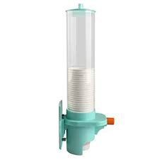

**Fig 3: One cup separator manually operated mechanism**

**Advantages:**

* Easy to operate than taking out cup from stack.
* More security to paper cup stack.

**Disadvantages:**

* No control over number of cups taken out.
* No control over position of cup with respect to water flow nozzle.

**4.2.3 Automatic Cup separator.**

The automatic cup separator uses an automatic mechanism to separate one cup from the stack when the coin is detected, the cup is then moved through guide to a specific location in correct orientation. This method is completely automatic and no need for customer interaction and also there is no possibility of wastage of the water due to misposition of the cup when water is poured. The mechanism is actuated using motor like a servo motor and it is given signal from the Arduino for its functioning. This method gives out only one cup and hence there is no risk of taking out more than one or all the cups from the stack.

**Advantages:**

* Complete automatic system without customer intervention.
* Only one cup separated from stack and position is also foolproof.

**Disadvantages:**

* Electrical power required.
* Reliability of mechanism comes into picture due to automation.

Considering all the factors above for security of the paper cups and for correct positioning the completely automatic mechanism for paper cup separation from stack is more appropriate than manual mechanisms.

**4.3.Heating System:**

**4.4 Water filling:**

The water can be filled in the cup using a tap like opening or closing of the solenoid valve to start or stop the flow of water from tank. This system can use different types of sensors for the measurement of the water in the cup. Following are different types of measurement systems that can be used.

**4.4.1Weight measuring of cup:**

The amount of water in the cup can be detected by measuring the weight of the cup while water is being filled in cup. This requires a pressure sensor to be placed at the position of cup. This has some problems as if the position of cup is offset to pressure sensor the reading given by it can change. Also the water spill from cup or during filling of water in cup. But this method has certain advantage as the measurement is direct and accurate.

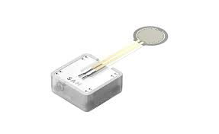

**Fig 4: Weight measuring cup**

**Advantages:**

* Direct measurement of water quantity.
* More reliable and accurate.

**Disadvantage:**

* Water spilling on sensor is possible.
* Accuracy depends upon position of cup.

**4.4.2 Water flow time control:**

The actual flow rate of the water can be considered as constant for one cup of water filling and hence by knowing volume, amount of time required for the opening of valve is known. In this case the flow rate will change depending upon the height of water or level of water in tank. Hence the water level has to be monitored before each cup filling. This can be done using an ultrasonic sensor which gives water level continuously for calculating the flow rate depending on the height.

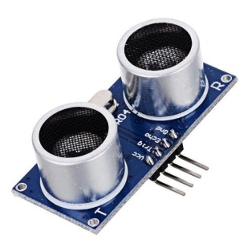

**Fig 5: Ultrasonic detector**

**Advantages**:

* No risk of contact of sensor and water.
* Easy time based operation.

**Disadvantages**:

* Measurement is indirect and depends on accuracy of calculations.
* Assumption of constant flow rate may not be useful in some conditions.

**4.4.3 Flow sensor:**

The flow sensor can be attached in series with the solenoid valve which consists of a small turbine connected to hall effect sensor. This flow sensor gives real time flow rate measurement and also can give actual water flow quantity in the cup. The sensor is very accurate and easy to use. Its working is independent of the position of cup or the water level in tank. This sensor is not depending on any other parameters like temperature or other environmental factors and gives fairly accurate readings and real time water quantity in cup.

**Advantages:**

* More direct measurement is done.
* Direct reading of amount of water irrespective of flow rate is obtained.

**Disadvantages:**

* Possibility of blockage of turbine can stop the readings.
* Calibration of flow sensor for low flow rate is difficult.

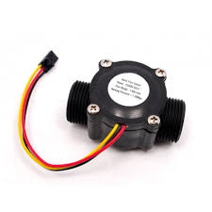

**Fig 6: Flow sensor**

Depending on the all above considerations, As the flow rate reduction due to flow meter is more, we use the time measurement for knowing when cup is filled.

**5. DESIGN**

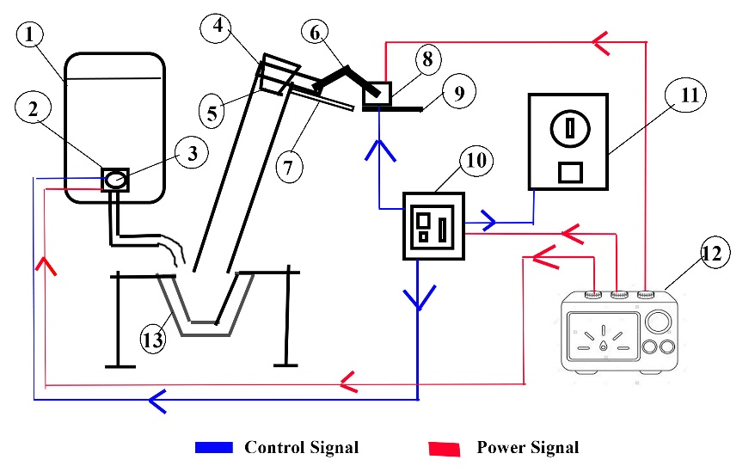

1.Water Dispenser 8. Servomotor

2.Solenoid Valve 9. Motor Support

3.Flow Sensor 10. Embedded Device (Arduino)

4.Recessed Slider 11. Coin Detector

5.Paper Glass 12. Power Supply

6.Linkage 13. Cup holder

7.Guides

**5.1 Coin Detector**

1. When user deposits coin into the slot on outside of machine, coin slot is dimensioned to the width and height for the thickest and largest diameter coin to be accepted.

2. Coin rolls down a chute and past identification probe that determines the denomination by the coin’s material properties. The probe consists of two solenoids with their axis perpendicular to the longitudinal wall of the chute.

3. Current is run through one solenoid which then generates Magnetic field perpendicular to the coin axis of revolution.  The magnetic field passes through the coin, is attenuated by the coin's material properties and geometry before being received by the solenoid at the opposite end.  The **B** field passing along the axis of the second coil generates a specific pattern of electric current, which can be matched with the correct coin.

4. The probe sends information to timing mechanism for turning on of electromagnetic device that opens flap armature.

5. Coin falls down chute. Coin rolls down chute.

DISPLAY INSERT THE COIN ON LCD

COIN ACCEPTED

CHECK PRESENCE OF GLASS

GLASS PLACED

START THE TAP FOR 10 sec

WATER DISPENSED

**5.2 Metering System**

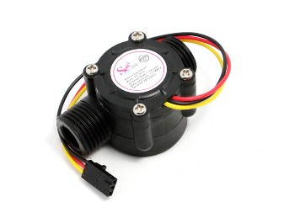

**Figure 7: Flow sensor**

**Description**

Water flow sensor consists of a plastic valve body, a water rotor, and a hall-effect sensor. When water flows through the rotor, rotor rolls. Its speed changes with different rate of flow. The hall-effect sensor outputs the corresponding pulse signal. This one is suitable to detect flow in water dispenser or coffee machine.

**Features**

* Compact, Easy to Install
* High Sealing Performance
* High Quality Hall Effect Sensor
* RoHS Compliant

**Specifications**

* Mini. working Voltage: 4.5V DC
* Max. Working Current: 15mA @5V DC
* Working Voltage: DC 5V to 24V
* Flow Rate Range: 1to 30 Litre/min
* Load Capacity: 10mA (DC 5V)
* Water Pressure: 1.75MPa
* Storage Temperature: -250C to + 80 0C

The pulse signal is in the form of a simple square wave so it’s quite easy convert into litres per minute using the following formula.

Pulse frequency (Hz) / 7.5 = flow rate in Litre/min.

**5.3 Cup Separator Mechanism:**

**5.3.1. Servo Motor**

The 10kg.cm torque is provided by Metal Gear Servo Motor - MG995 which can rotate approximately 180 degrees (90 in each direction).

It can be used with hardware  or  library  to  control  these  servos,  so  it's  great.  The MG995 Metal Gear Servo also has a selection of arms and hardware to get nice set up.

**Features:**

* Operating voltage: 4.8 V to 7.2 V
* Temperature range: 0 ºC to 55 ºC
* Control System: Analog
* Operating Angle: 180degree
* Weight: 55 g
* Dimension: 40.7 x 19.7 x 42.9 mm approx.
* Stall torque: 8.5 kgf·cm (4.8 V ), 10 kgf·cm (6 V)
* Stable and shock proof double ball bearing design.

**5.3.2 Cup Separator:**

Cup separator is made with slot included in it so that the paper cup of diameter 75 mm may accommodate with its rounded edge. This mechanism need a stack of the paper glass above it in fixed position. So, that when the crank attached to the servo motor, rotates and gives linear motion to the cup separator shown in the figure.

The paper glass then falls due to gravity through the PVC pipe. This pipe has diameter greater than paper glass so that it should pass easily without any resistance. Guides in the shape of C section are attached to the main mechanism to impart the sustainability towards vertical and horizontal displacements.

Wedge angle is fixed after iterations to provide the easy and simple movement of paper glass inside the slot. This wedge also connects the guides of C sections attached to the mechanism to the base.

For the given sider-crank mechanism;

Total required displacement of the mechanism=18cm

So, length of crank= (Mechanism displacement/2) = 9cm

Connecting rod length can be taken above 10cm to the 22cm……… (Since, the sum of any two sides of triangle must be greater than other side)

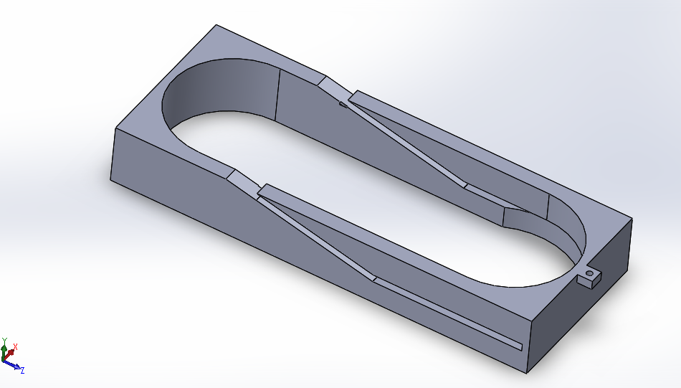

**Figure 8: Cad model of coin separator mechanism**

**6. CONTROLLING UNIT**

Aurdiuno is open-source hardware and software company, project and user community that designs and manufactures single-board microcontrollers and microcontroller kits for building digital devices and interactive objects that can sense and control objects in the physical and digital world. Its products are licensed under the GNU Lesser General Public License (LGPL) or the GNU General Public License (GPL), permitting the manufacture of Arduino boards and software distribution by anyone. Arduino boards are available commercially in preassembled form or as do-it-yourself (DIY) kits.

Arduino board designs use a variety of microprocessors and controllers. The boards are equipped with sets of digital and analog input/output (I/O) pins that may be interfaced to various expansion boards or breadboards (*shields*) and other circuits. The boards feature serial communications interfaces, including Universal Serial Bus (USB) on some models, which are also used for loading programs from personal computers. The microcontrollers are typically programmed using a dialect of features from the programming languages C and C++. In addition to using traditional compiler toolchains, the Arduino project provides an integrated development environment (IDE) based on the Processing language project.

**6.1 Hardware:**

Arduino is open-source hardware. The hardware reference designs are distributed under a Creative Commons Attribution Share-Alike 2.5 license and are available on the Arduino website. Layout and production files for some versions of the hardware are also available.

Although the hardware and software designs are freely available under copyleft licenses, the developers have requested the name Arduino to be exclusive to the official product and not be used for derived works without permission. The official policy document on use of the Arduino name emphasizes that the project is open to incorporating work by others into the official product. Several Arduino-compatible products commercially released have avoided the project name by using various names ending in arduino.

An early Arduino board with an RS-232 serial interface (upper left) and an Atmel ATmega8 microcontroller chip (black, lower right); the 14 digital I/O pins are at the top, the 6 analog input pins at the lower right, and the power connector at the lower left.

Most Arduino boards consist of an Atmel 8-bit AVR microcontroller (ATmega8, ATmega168, ATmega328, ATmega1280, ATmega2560) with varying amounts of flash memory, pins, and features. The 32-bit Arduino Due, based on the Atmel SAM3X8E was introduced in 2012.The boards use single or double-row pins or female headers that facilitate connections for programming and incorporation into other circuits. These may connect with add-on modules termed shields. Multiple and possibly stacked shields may be individually addressable via an I²C serial bus. Most boards include a 5 V linear regulator and a 16 MHz crystal oscillator or ceramic resonator. Some designs, such as the Lily Pad, run at 8 MHz and dispense with the on-board voltage regulator due to specific form-factor restrictions.

**6.2 Software:**

A program for Arduino hardware may be written in any programming language with compilers that produce binary machine code for the target processor. Atmel provides a development environment for their 8-bit AVR and 32-bit ARM Cortex-M based microcontrollers: AVR Studio (older) and Atmel Studio (newer).

**6.3 IDE:**

The Arduino integrated development environment (IDE) is a cross-platform application (for Windows, macOS, Linux) that is written in the programming language Java. It originated from the IDE for the languages Processing and Wiring. It includes a code editor with features such as text cutting and pasting, searching and replacing text, automatic indenting, brace matching, and syntax highlighting, and provides simple one-click mechanisms to compile and upload programs to an Arduino board. It also contains a message area, a text console, a toolbar with buttons for common functions and a hierarchy of operation menus. The source code for the IDE is released under the GNU General Public License, version 2.

The Arduino IDE supports the languages C and C++ using special rules of code structuring. The Arduino IDE supplies a software library from the Wiring project, which provides many common input and output procedures. User-written code only requires two basic functions, for starting the sketch and the main program loop, that are compiled and linked with a program stub main() into an executable cyclic executive program with the GNU toolchain, also included with the IDE distribution. The Arduino IDE employs the program avrdude to convert the executable code into a text file in hexadecimal encoding that is loaded into the Arduino board by a loader program in the board's firmware.

**6.4 Flow chart and Program:**

When someone insert coin in coin detector mechanism and coin is detected by coin detector. The signal from coin detector is given to arduino. Aurdiuno send signal to servomotor and servomotor rotates by 10 degree forward, again 70 degree forward and again backward 10 degree. After that solenoid valve is operated and flow sensor started. If total flow is greater than 200 ml then solenoid valve stopped.

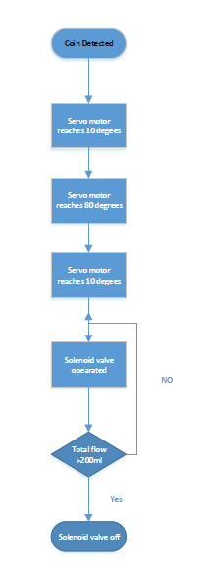

**Code used for given application:**

*#include <Servo.h>*

*int wat=0;*

*byte statusLed = 13;*

*Servo myservo;*

*byte sensorInterrupt = 2; // 0 = digital pin 2*

*byte sensorPin = 2;*

*byte ser=3;*

*byte coin=4;*

*byte valve=5;*

*// The hall-effect flow sensor outputs approximately 4.5 pulses per second per*

*// litre/minute of flow.*

*float calibrationFactor = 4.5;*

*volatile byte pulseCount;*

*float flowRate;*

*unsigned int flowMilliLitres;*

*unsigned long totalMilliLitres;*

*totalMilliLitres = 0;*

*unsigned long oldTime;*

*void setup()*

*{*

*// Initialize a serial connection for reporting values to the host*

*Serial.begin(9600);*

*pinMode(ser,OUTPUT);*

*pinMode(valve,OUTPUT);*

*pinMode(coin,INPUT);*

*pinMode(sensorPin, INPUT);*

*digitalWrite(sensorPin, HIGH);*

*myservo.attach(ser);*

*pulseCount = 0;*

*flowRate = 0.0;*

*flowMilliLitres = 0;*

*oldTime = 0;*

*// The Hall-effect sensor is connected to pin 2 which uses interrupt 0.*

*// Configured to trigger on a FALLING state change (transition from HIGH*

*// state to LOW state)*

*attachInterrupt(sensorInterrupt, pulseCounter, FALLING);*

*attachInterrupt(coin,coinfun,RISING);*

*}*

*void mechanism()*

*{*

*myservo.write(10); // sets the servo position according to the scaled value*

*delay(2000);*

*myservo.write(80); // sets the servo position according to the scaled value*

*delay(2000);*

*}*

*void flow()*

*{*

*if((millis() - oldTime) > 1000) // Only process counters once per second*

*{*

*detachInterrupt(sensorInterrupt);*

*flowRate = ((1000.0 / (millis() - oldTime)) * pulseCount) / calibrationFactor;*

*oldTime = millis();*

*flowMilliLitres = (flowRate / 60) * 1000;*

*// Add the millilitres passed in this second to the cumulative total*

*totalMilliLitres += flowMilliLitres;*

*if(totalMilliLitres>=100)*

*wat=1;*

*else*

*wat=0;*

*unsigned int frac;*

*// Print the flow rate for this second in litres / minute*

*Serial.print("Flow rate: ");*

*Serial.print(int(flowRate)); // Print the integer part of the variable*

*Serial.print("L/min");*

*Serial.print("\t"); // Print tab space*

*// Print the cumulative total of litres flowed since starting*

*Serial.print("Output Liquid Quantity: ");*

*Serial.print(totalMilliLitres);*

*Serial.println("mL");*

*Serial.print("\t"); // Print tab space*

*Serial.print(totalMilliLitres/1000);*

*Serial.print("L");*

*// Reset the pulse counter so we can start incrementing again*

*pulseCount = 0;*

*// Enable the interrupt again now that we've finished sending output*

*attachInterrupt(sensorInterrupt, pulseCounter, FALLING);*

*}*

*}*

*void pulseCounter()*

*{*

*// Increment the pulse counter*

*pulseCount++;*

*}*

*void coinfun()*

*{*

*delay(2000);*

*mechanism();*

*delay(2000);*

*wat=0;totalMilliLitres = 0;*

*while(wat==0)*

*{*

*digitalWrite(valve,1);*

*flow();*

*}*

*digitalWrite(valve,0);*

*delay(1000);*

*}*

**7. FABRICATION**

Different components like Cup separator, Cup separator mechanism, Sliders for separator, Guide for cup, Frame, Cup stack support are fabricated by using available facilities in our college.

**7.1 Cup separator:**

The cup separator part is very intricate and the diameters of different parts are varying, it requires large amount of accuracy in manufacturing. The part can be made using wood, foam or other different materials. Making this part by wood is difficult and can be made easily with foam but the strength is very less in polyurethane foam material.

The 3d printing technology is the very easy and useful in making the intricate shapes.

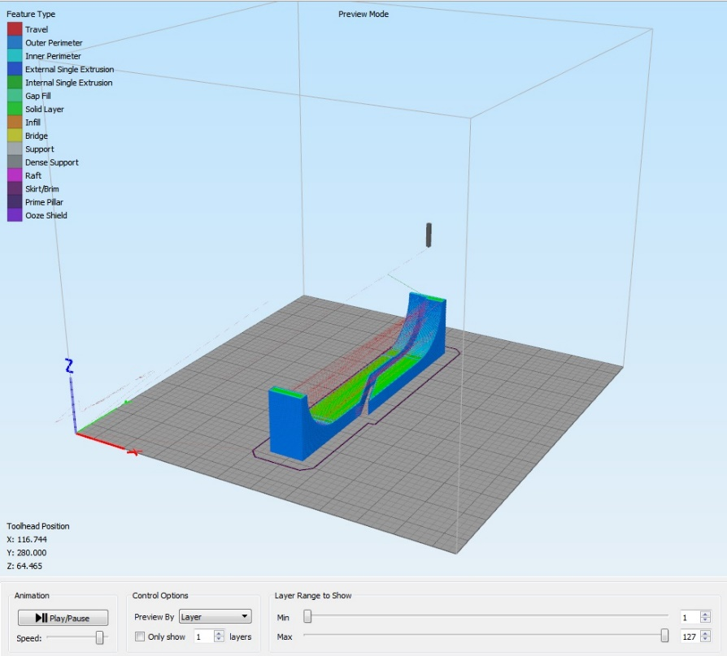

**Figure 9: Cup separator mechanism CURA CAM simulation**

For the printing cup separator mechanism we use material as ABS with density 30% layer height .35mm and surface temperature 200 degree Celsius and support temperature 60 degree Celsius. Two separate parts made which is 3D printed are joined together using flex quick adhesive. This makes complete cup separator part.

**7.2 Cup separator Mechanism**

The Cup separator part made has to make linear motion to perform the separation. The linear motion is to be given using slider crank mechanism. The mechanism consists of the one connecting rod and crank used to move separator working as slider. The total travel of the separator is 11 cm and hence the crank length comes to 5.5 cm. These links are joined to the slider using foam board flex quick adhesives. The connecting rod having fewer loads is made of foam board but the crank on which more load is there the link is made of aluminium. The mechanism is actuated by servo motor which is fixed to the frame using wood support. The servo has 180 degrees of complete travel out of which 70 degrees of travel is used for actuating the slider mechanism.

.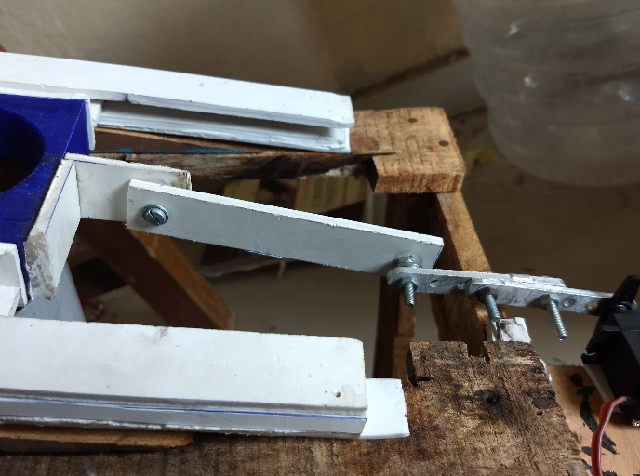

**Fig 10: Cup separator Mechanism**

**7.3 Sliders for mechanism:**

The slider crank mechanism gives the linear motion to the separator but the separator slider should have a proper support for sliding with minimum friction. The separator is attached with slider flanks which slide in a c shaped slider. The flanks and slides are made of polyurethane foam to reduce the friction. The slides are given a certain angle of 8 degrees for easy cup separation. This angle is given using a wedge shaped wood block attached to frame using fevicol and the slide are attached to these wedges using double side tape and adhesives.

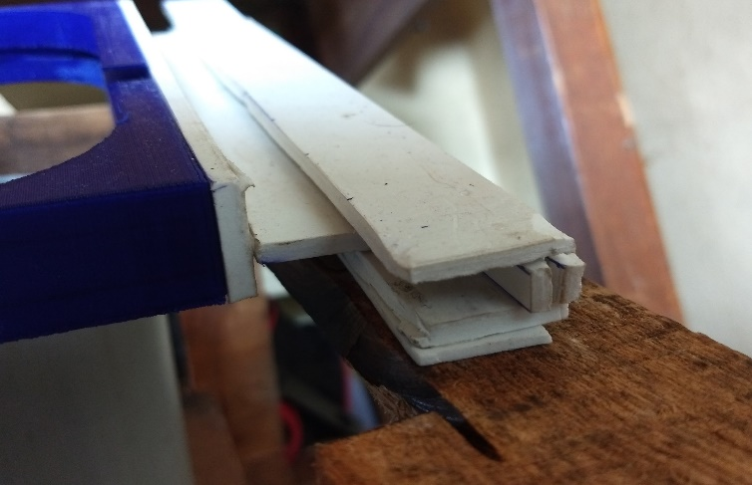

**Figure 11: Sliders for mechanism**

**7.4 Guide for cup:**

PVC pipe is fixed to the frame which is used to give support to the cup separated using mechanism. This PVC pipe is inserted in pocket made on plywood attached to the wooden frame. The circular pocket is made using profile cutting operation. This pipe is then rested on the main frame. So, by using these two supports the vertical and horizontal motion is restricted. The pipe is having an inner diameter more than cup size.

The pipe is also given a inclination for moving the cup offset from stack axis for easy water inlet. The cup stand is provided at bottom of the pipe for holding the cup in correct position. The cup holder is a fixture made out of a cardboard box with funnels shaped extension given with another paper cup.

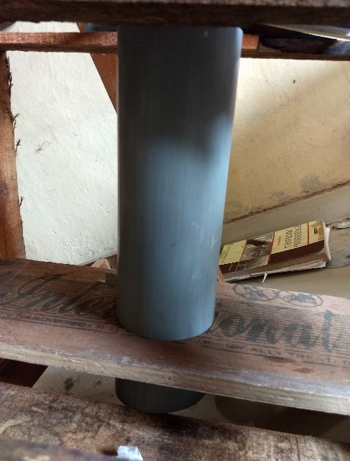

**Fig 12: Cup guide pipe**

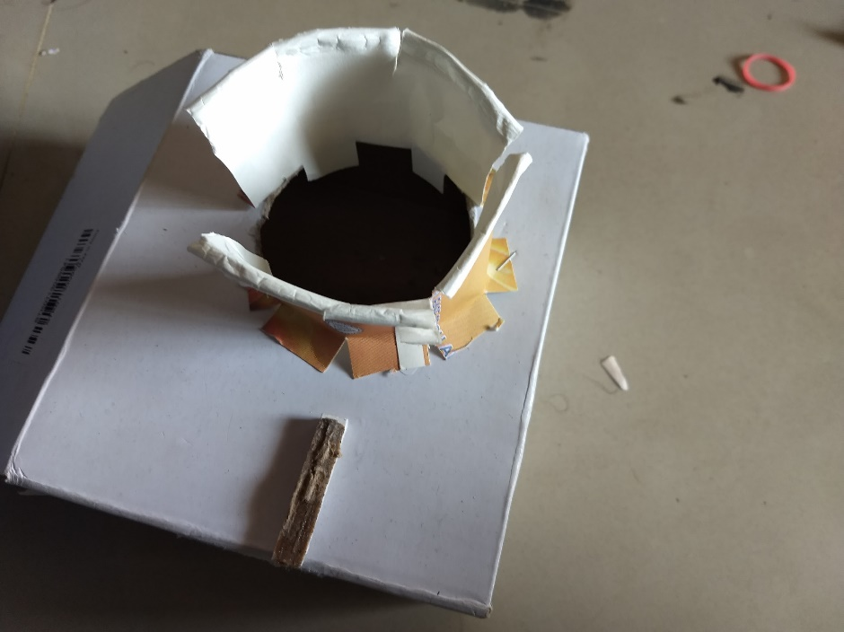

**Fig 13: Cup holder.**

**7.5 Frame**

The frame is a wooden skeleton which supports various components of the setup like mechanism, sliders, coin detector, Aurdiuno, battery.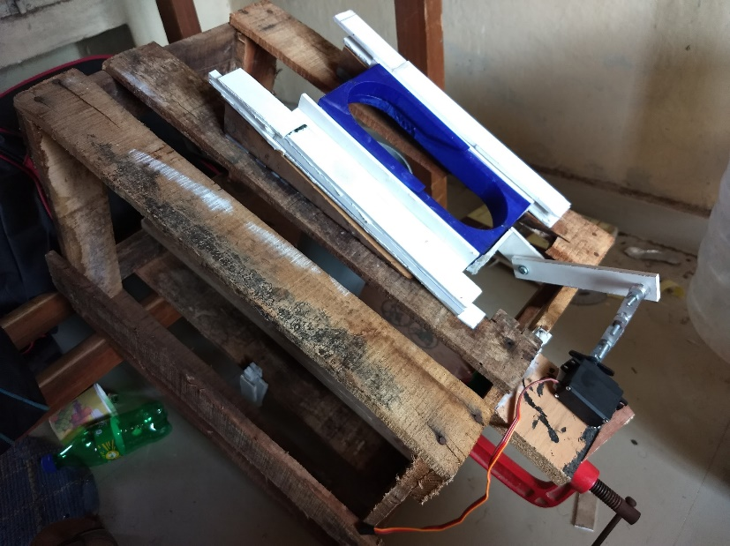

**Fig 14: Cup stack support**

**7.6 Cup stacks support:**

The stack of paper cup is to remain stable and not move with the slider. This can achieve by a stack support obtained by using pipe of about 75 mm diameter. This pipe is given support from the frame with wooden supports which are fixed using nails to the frame. The stability of the pipe depends on the stability of the frame.

**8. COST ANALYSIS**

**Description:**

**EXPECTED INITIAL INVESTMENT COSTING:**

|  |  |  |  |
| --- | --- | --- | --- |
| **Item No** | **Name** | **Function** | **Cost(INR)** |
| 1 | Arduino Mega | Control System | 1500 |
| 2 | 12 V lipo Battery | Power supply | 2500 |
| 3 | 3d printing material | Cup dispenser Mechanism | 1500 |
| 4 | Servo motor | Cup dispenser Mechanism | 1200 |
| 5 | Solenoid Valve | Flow control | 1000 |
| 6 | Flow meter | Flow measurement | 800 |
| 7 | Coin Detector | Coin detection | 800 |
| 8 | Tank1(20 ltr) | Water storage | 200 |
| 9 | Tank2(2ltr) | Water storage | 300 |
| 10 | Aluminium linkages | Cup dispenser Mechanism | 100 |
| 11 | PVC pipe | Cup movement | 100 |
| 12 | Steel frame | Cup holder support | 200 |
| 13 | Plastic pipe 1/4'' | Water flow | 200 |
| 14 | Sliders | Mechanism support | 300 |
|  |  | **Total** | **10,700** |

**Description**

**Case A.**

For organisation like Bisleri if considered to vend-

* We get, 20 L of water for 90 INR

Therefore, Cost per 200ml glass of water = **0.9 Rs**

* Considering cost of 100 glasses for 45 Rs,

Cost of 1 glass (200 ml) is **0.45 Rs**

* Electric Overhead costs per glass of water-

Calculated electricity required for-

* + - * 1. Servo motor and mechanism
        2. Solenoid Valve actuation
        3. Coin Detection unit
        4. Controlling unit like Aurdiuno

Comes out to be 0.33 W-hr,

And assuming that per unit of electricity is 2.5 Rs

Electric overhead charges for 1 Glass of Water=**0.000825 Rs**

* Assumed, 50 Rs maintenance cost per day(Electrical and mechanical maintenance)

Considering that 150L of water consumed at a particular vending station per day (Bus and railway stations)

Therefore, 750 paper glasses of 200ml are utilized per day.

Thus maintenance costs per glass of water are **0.06667 Rs**.

* Thus total Cost Price for 1 glass of water

= Water costs + Paper glass cost + Electrical overhead cost + Maintainance Costs

=**0.9 Rs+0.45 Rs+0.000825 Rs+0.06667 Rs**

=**1.4175 Rs**

* Considering a Profit margin of **40% (0.58 Rs)**
* Selling price for 1 glass of water= **2 Rs**
* Thus Payback period or Return On Investment

=10700 Rs initial Investment/(750 Glass per day * 0.58 Rs per glasss)

=25 days (ROI).

**Case 2**

For government organisations like Tata Trusts if considered to vend-

* We get, 20 L of water for 5 INR

Therefore, Cost per 200ml glass of water = **0.25 Rs**

* Considering cost of 100 glasses for 45 Rs,

Cost of 1 glass (200 ml) is **0.45 Rs**

* Electric Overhead costs per glass of water-

Calculated electricity required for-

* + - * 1. Servo motor and mechanism
        2. Solenoid Valve actuation
        3. Coin Detection unit
        4. Controlling unit like Arduino

Comes out to be 0.33 W-hr,

And assuming that per unit of electricity is 2.5 Rs

Electric overhead charges for 1 Glass of Water=**0.000825 Rs**

* Assumed, 50 Rs maintenance cost per day(Electrical and mechanical maintenance)

Considering that 150L of water consumed at a particular vending station per day( Bus and railway stations)

Therefore, 750 paper glasses of 200ml are utilized per day.

Thus maintenance costs per glass of water are **0.06667 Rs**.

* Thus total Cost Price for 1 glass of water

= Water costs + Paper glass cost + Electrical overhead cost + Maintenance Costs

=**0.25 Rs+0.45 Rs+0.000825 Rs+0.06667 Rs**

=**0.7675 Rs**

* Considering a Profit margin of **30% (0.43 Rs)**
* Selling price for 1 glass of water= **1 Rs**
* Thus Payback period or Return On Investment

=10700 Rs initial Investment/(750 Glass per day * 0.43 Rs per glass)

=34 days (ROI).

**9. CONCLUSION-**

1. **Eco-friendly**-The product involves use of paper cups which supports plastic ban campaign.
2. **Cost-effective**-Cost per 200ml ( A glass of water ) can be brought to an effective value of 2 to 1 Rs.
3. **Fully Automatic**- Since the product involves use of Arduino, fully automated system is built.
4. **Customizable**-Any future extensions can be built in the product as per the customers demand.
5. **Reprogrammable**-With the use of Arduino involved the product can be reprogrammed with ease for different flow rates and payment systems.

**10. PROJECT WORK FLOW**

|  |  |  |  |
| --- | --- | --- | --- |
|  | Planned Activity |  | Completed Activity |

|  |  |  |  |  |  |  |  |  |  |  |  |  |  |  |  |  |  |  |  |
| --- | --- | --- | --- | --- | --- | --- | --- | --- | --- | --- | --- | --- | --- | --- | --- | --- | --- | --- | --- |
| Work Activity by weeks | July | | | | August | | | | | September | | | | October | | | | November | |
| 1st | 2nd | 3rd | 4th | 1st | 2nd | 3rd | 4th | 1st | | 2nd | 3rd | 4th | 1st | 2nd | 3rd | 4th | | 1st |
| Literature Review |  |  |  |  |  |  |  |  |  | |  |  |  |  |  |  |  | |  |
|  |  |  |  |  |  |  |  |  | |  |  |  |  |  |  |  | |  |
| Problem Identification |  |  |  |  |  |  |  |  |  | |  |  |  |  |  |  |  | |  |
|  |  |  |  |  |  |  |  |  | |  |  |  |  |  |  |  | |  |
| Brainstorming and Benchmarking |  |  |  |  |  |  |  |  |  | |  |  |  |  |  |  |  | |  |
|  |  |  |  |  |  |  |  |  | |  |  |  |  |  |  |  | |  |
| Product Definition and Parts Classification |  |  |  |  |  |  |  |  |  | |  |  |  |  |  |  |  | |  |
|  |  |  |  |  |  |  |  |  | |  |  |  |  |  |  |  | |  |
| Synopsis  Submission |  |  |  |  |  |  |  |  |  | |  |  |  |  |  |  |  | |  |
|  |  |  |  |  |  |  |  |  | |  |  |  |  |  |  |  | |  |
| Procurement of required parts and equipment. |  |  |  |  |  |  |  |  |  | |  |  |  |  |  |  |  | |  |
|  |  |  |  |  |  |  |  |  | |  |  |  |  |  |  |  | |  |
| Program Algorithm for control ckts. |  |  |  |  |  |  |  |  |  | |  |  |  |  |  |  |  | |  |
|  |  |  |  |  |  |  |  |  | |  |  |  |  |  |  |  | |  |
| Part and Assembly Drawings |  |  |  |  |  |  |  |  |  | |  |  |  |  |  |  |  | |  |
|  |  |  |  |  |  |  |  |  | |  |  |  |  |  |  |  | |  |
| Fabrication of working prototype |  |  |  |  |  |  |  |  |  | |  |  |  |  |  |  |  | |  |
|  |  |  |  |  |  |  |  |  | |  |  |  |  |  |  |  | |  |
| Report  Submission  And Presentation |  |  |  |  |  |  |  |  |  | |  |  |  |  |  |  |  | |  |
|  |  |  |  |  |  |  |  |  | |  |  |  |  |  |  |  | |  |

**11. REFERENCES**

**[1]** Tooru Kajimura, Nobuhiko Kametani and Toshihisa Miyagishi, (2000) “Present Status

and Future Prospects of Vending Machines”, FUJI ELECTRIC REVIEW, Volume 49, Issue

1.

**[2]** Web Finance, Inc. (2011). Business Dictionary. Retrieved May 27, 2011, from Business

Dictionary.com: http://www.businessdictionary.com/definition/vending-machine.html.

[3] Answers Corporation. (2011). Vending Machine. Retrieved May 27, 2011, from

Answers.com: http://www.answers.com/topic/vending-machine.

[4] Donaldson, K., Ishii, K., &amp; Sheppard, S. (2006). Customer Value Chain Analysis.

Research in Engineering Design ,16 (Springer-Verlag London Limited 2006), 175-177.

**[5]** Hitesh D. (Bhardwaj) Suman ,(1907) “Research Paper On Change Required in the

Method Of Insurance Payment Through AVM’s (Automated Vending Machine) In India”,

Copyright Reserved under Indian Copyright Act).

**[6]** Kervin, J. B. (1992). “Methods for business research”. New York: HarperCollins

Publishers Inc.

**[7]** Keyton, J. (2006). Communication Research. Available at

http://highered.mcgrawhill.com/sites/0073049506/student_view0/glossary.html .Tata

McGraw-Hill. Second Edition. Accessed by [22nd August,2018].

**[8]** Bernard, E., &amp; Legeard, B. (2008). “Requirements Traceability in the Model-Based

Testing”. LEIRIOS Technologies, LEIRIOS GmbH.

**[9]** Alfonso Carlosena, Antonio J López-Martín, Fernando Arizti, Ane Martínez-de-Guerenu ,

José L. Pina-Insausti and J. Miguel García-Sayés Universidad Publican de Navarra, E-31006

Pamplona, Spain, carlosen@unavarra.es.

**[10]** Jesus E. Ibarrola and Jose L. P. [1993-06-11] patent no :US08075242

**[11]** Friedrich. Graffen berger, Patent name: “Cup-Dispensing Machine”, Patent No:1666008,

Date of Grant: 10/04/1928, USA.

**[12]** Ria Sood1 , Manjit Kaur2 , Hemant Lenka3 International Journal of Computer Science,

Engineering and Applications (IJCSEA) Vol.3, No.3, June 2013.

**[13]** L. T. Leet liquid vending machine filed oct 11 1924 2 sheets-sheet 1 inventor lyn/v r lee

r attorneys oct. 12 1926.